Top 10 Largest Forts in India: Explore India's Biggest Historic Fortresses

If you admire history and feel spellbound by architecture or just planning your next trip to India, then you would not want to miss these biggest Forts in India. Several of these historic sites are designated as UNESCO World Heritage Sites while others continue to impress visitors with their massive walls, royal palaces, ancient temples, and breathtaking panoramic views.

Across the globe the most spectacular forts are found in India, each a testament to centuries of fighting, kingship, and architectural genius. Be it the grand walls of Rajasthan's hill forts or the citadel brilliance of Uttar Pradesh, Delhi, Telangana and Madhya Pradesh, there's no denying that these structures have witnessed the rise and fall of kingdoms, legendary battles, and remarkable cultural transformations.

Though there are numerous enchanting forts in India, however to make things less complicated Fort in Rajasthan has come up with a list of 10 largest and dominant forts with maximum visitors.

Following are the 10 largest forts that Indians are proud of:

- Chittorgarh Fort, Rajasthan

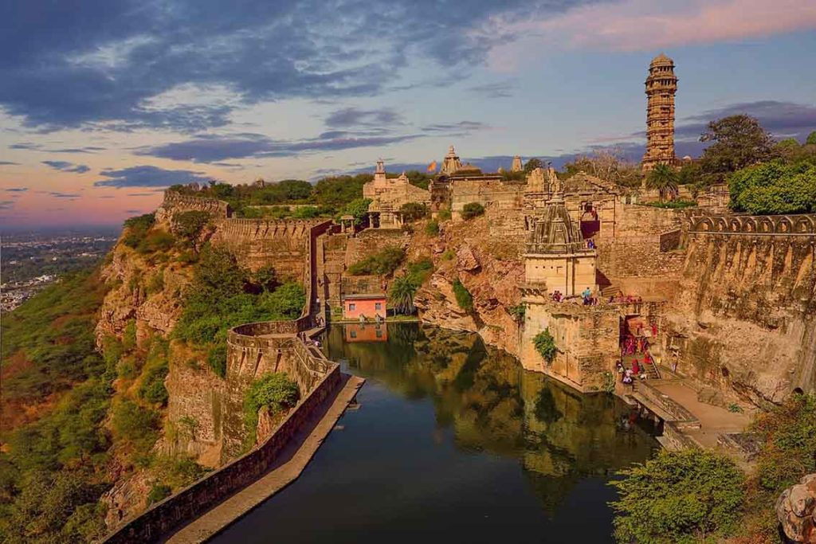

Chittorgarh Fort is often known as the biggest fort in India and it stands tall over the Berach River plains. Spanning almost 700 acres, this UNESCO World Heritage Site was the ancient capital of the Mewar Kingdom and continues to be one of Rajasthan's greatest reminders of bravery and sacrifice.

HIGHLIGHTS

- Vijay Stambh (Victory Tower)
- Rana Kumbha Palace
- Rani Padmini Palace
- Over 80 historic water bodies

Best Time to Explore: October to March

- Kumbhalgarh Fort, Rajasthan

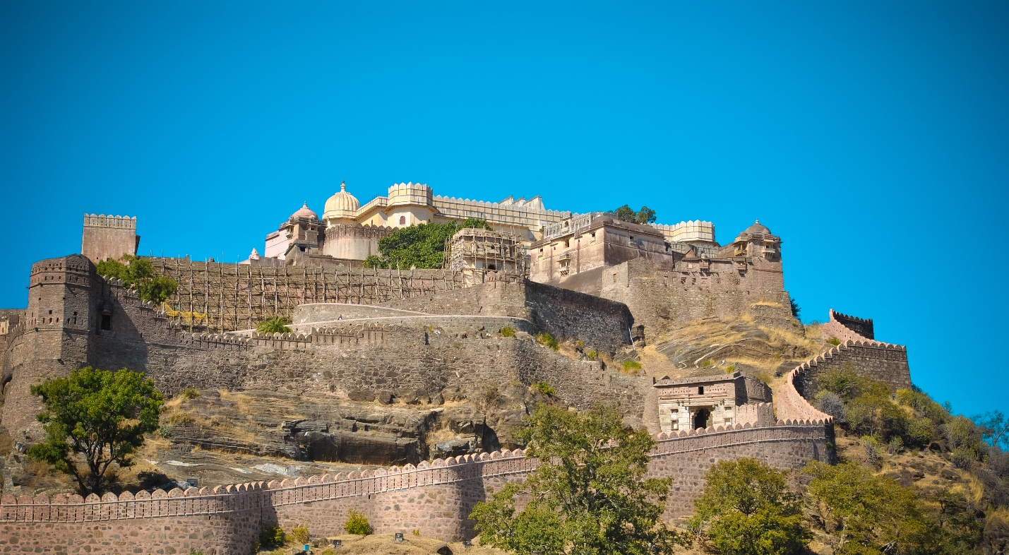

Resting in the lap of Aravalli Hills, the Kumbhalgarh Fort is known for its impressive 36 kilometer long defensive wall which has earned it recognition as the second longest continuous wall in the world after the Great Wall of China.

This UNESCO listed fort was constructed during the 15th century AD by Rana Kumbha and is recognized as one of the finest examples of Rajput military architecture.

HIGHLIGHTS

- World's second-longest fort wall
- Birthplace of Maharana Pratap
- Over 300 temples
- Panoramic Aravalli views

Best Time to Explore: Mid October to February

- Mehrangarh Fort, Rajasthan

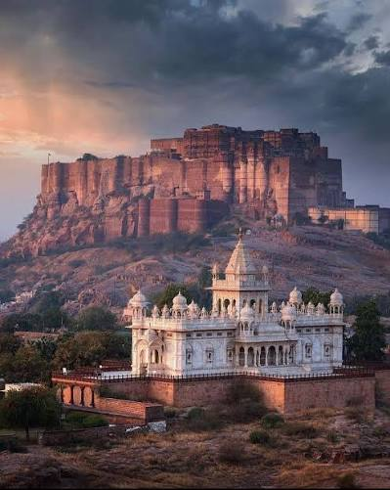

Filled with panoramic views from a height of almost 410 feet above the city, towering walls and splendorous Rajput architecture, Mehrangarh Fort is considered as the pride of Jodhpur.

Inside the fort, you can see exquisitely decorated palaces, lattice windows, sprawling courtyards and museums adorned with royal artifacts.

It even provides stunning panoramic sights of Jodhpur's Blue City, making it among the most photographed spots in Rajasthan.

HIGHLIGHTS

- Sheesh Mahal
- Phool Mahal
- Fort Museum
- Zipline adventure overlooking Jodhpur

Best Time to Explore: October to March

- Gwalior Fort, Madhya Pradesh
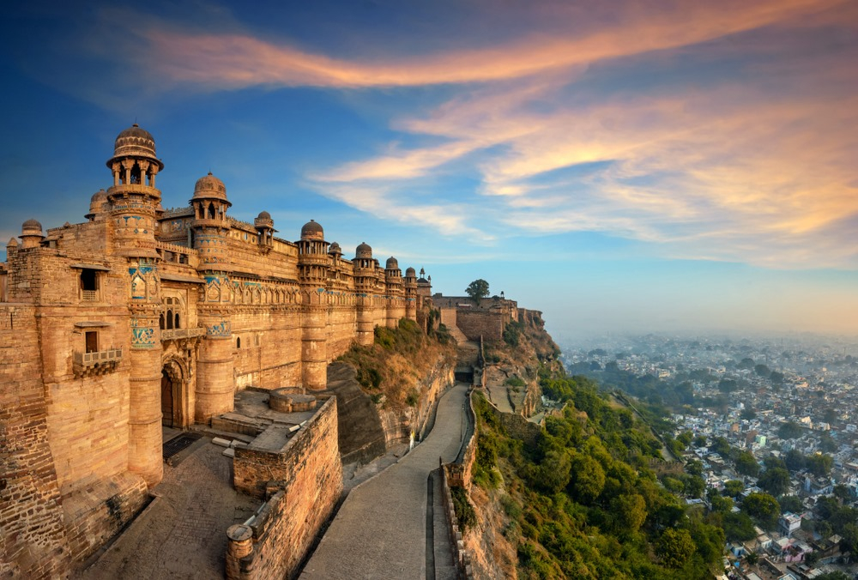

Standing on a sandstone hill, the 1,000-year-old Gwalior Fort has been an invincible sentinel of central India. Given its strategically important position, it is often referred to as "The Gibraltar of India," while its incredible architecture has intrigued historians and travelers alike.
The fort was ruled over by the Tomars, Mughals, Marathas and Scindias in between centuries, stamping their signature architectural style as they left.
HIGHLIGHTS
- Man Singh Palace
- Gujari Mahal Museum
- Teli Ka Mandir
- Light & Sound Show
Best Time to Explore: October to March
- Red Fort, Delhi

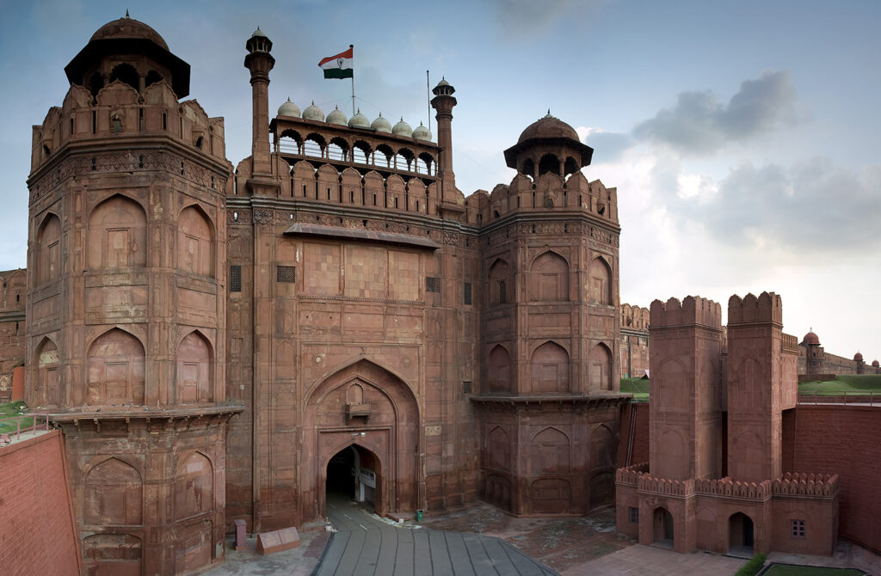

The Red Fort, constructed in 1639 by Emperor Shah Jahan is one of the most recognized historical monuments in India and also a UNESCO world heritage site.
Stretched over 254 acres, the fort was centered around politics and culture for almost 200 years of the Mughal Empire.
Constructed mostly from the famous red sandstone, it features a harmonious blend of Persian, Timurid and Indian styles. Today, it continues to serve as a reminder of India's independence with the Prime Minister giving the traditional Independence Day speech from its historic ramparts every year.
HIGHLIGHTS
- Lahori Gate
- Diwan-i-Aam
- Diwan-i-Khas
- Mumtaz Mahal Museum
- Light & Sound Show
Best Time to Explore: October to February
- Golconda Fort, Telangana
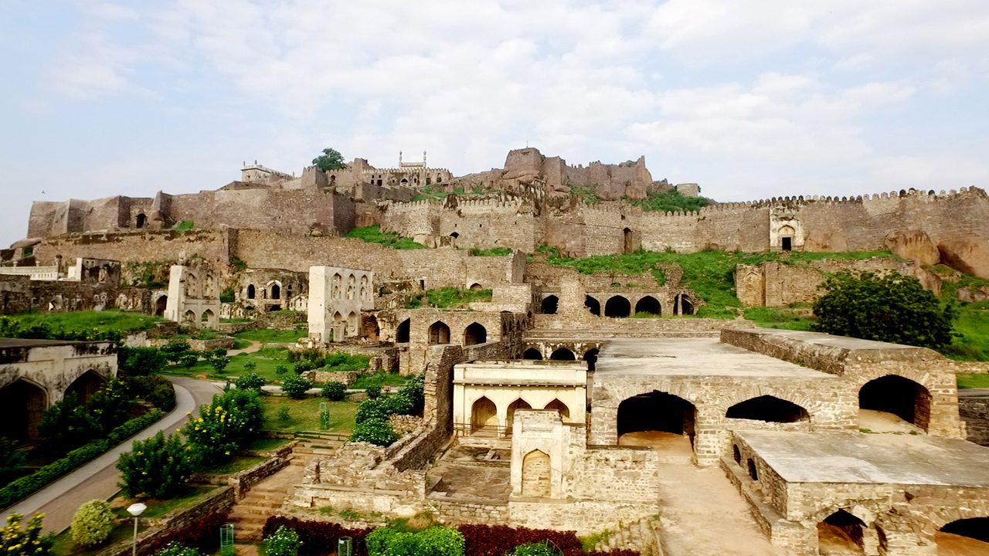

Located on the edge of Hyderabad, Golconda Fort is one of the biggest forts in India and a marvel of medieval military engineering. Built in the 12th century by the Kakatiya Dynasty and further developed by Qutb Shahi rulers, this fort led to establishing one of the richest kingdoms of India.
Golconda is chiefly known for its links with the world famous Kohinoor Diamond and many other glittering gems traded here in its then bustling markets.
HIGHLIGHTS
- Advanced acoustic engineering
- Secret underground passages
- Qutb Shahi architecture
- Evening Light & Sound Show
Best Time to Explore: October to February
- Jaisalmer Fort, Rajasthan

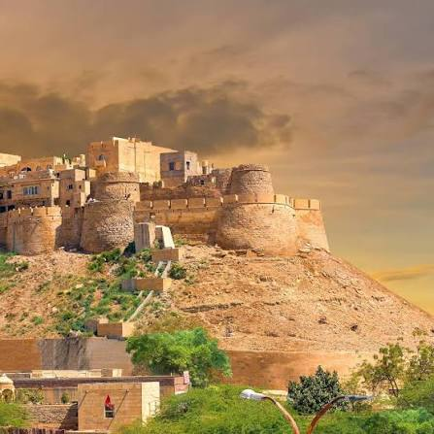
Unlike many historical forts that now function as monuments, Jaisalmer Fort is one of the few remaining living forts in the world, where thousands still live within its ancient walls. Constructed in 1156 based on the desires of Maharaja Rawal Jaisal, the fort sits high above the golden sands painted with hues of brown from its surrounding Thar Desert.
Within the bounds of this enormous fort, you can find an entire world bursting with colourful towns and centuries old Jain temples, picturesque havelis, local bazaars, etc.
HIGHLIGHTS
- UNESCO World Heritage Site
- Restored as one of the few living forts in the world
- Laxminath Temple
- Spectacular Sunset View on Thar Desert
Best Time to Explore: October to March
- Agra Fort, Uttar Pradesh
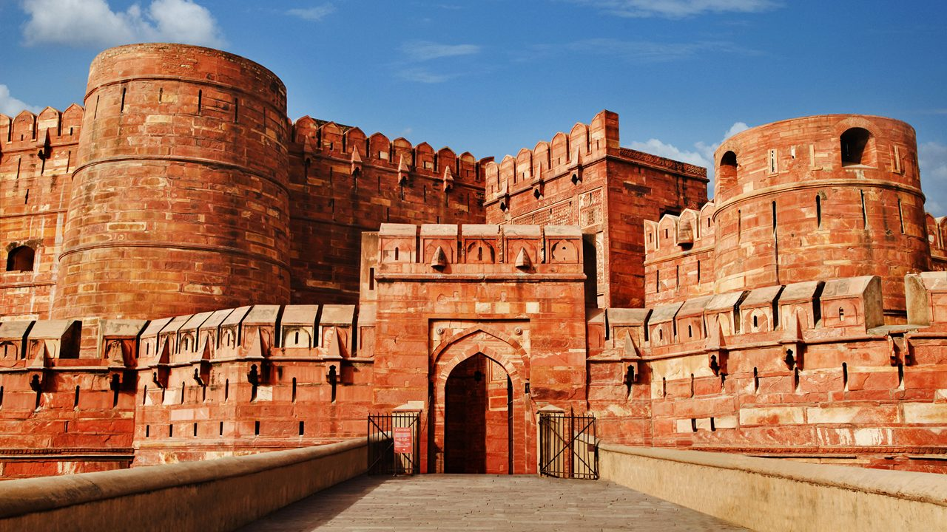

Though often overshadowed by the Taj Mahal, Agra Fort is just as important when it comes to painting a picture of grandeur in Mughal style. Constructed in 1565 by Emperor Akbar and further improved by Shah Jahan, this UNESCO World Heritage Site was the main house of the Mughal emperors until the capital was moved to Delhi.
Among its most poignant historical ties is the fact that Shah Jahan spent his last years imprisoned here, staring over the Yamuna River at the Taj Mahal.
HIGHLIGHTS

- Diwan-i-Khas
- Diwan-i-Aam
- Sheesh Mahal
- Amazing views of Taj Mahal
Best Time to Explore: November to March
- Kangra Fort, Himachal Pradesh

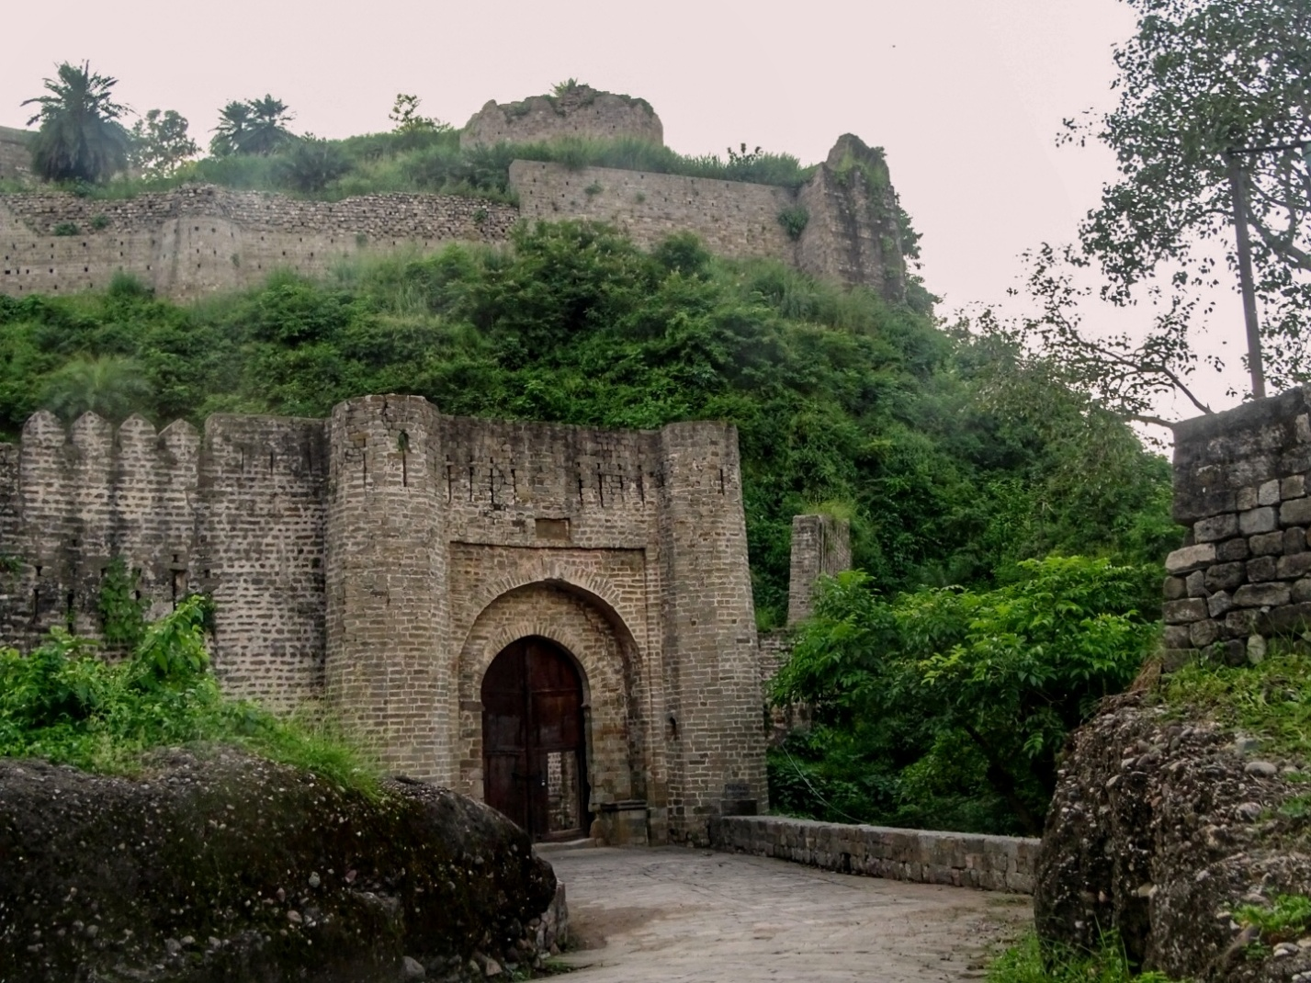
Kangra Fort, located in the stunning Kangra Valley is also believed to be one of the oldest forts in India with its history dating back over 3000 years. The fortress was built by the Katoch Dynasty and has seen simultaneous invasions by rulers such as Mahmud Ghazni, Mughals, Sikhs and the British.
There is so much to see in this ancient hill top settlement boasting not only its medieval gateways and temples, but also breathtaking views of the mighty Himalayas.
HIGHLIGHTS
- One of India's oldest forts
- Fort Museum
- Panoramic Himalayan views
- Historic treasure wells
Best Time to Explore: March to July
- Panhala Fort, Maharashtra
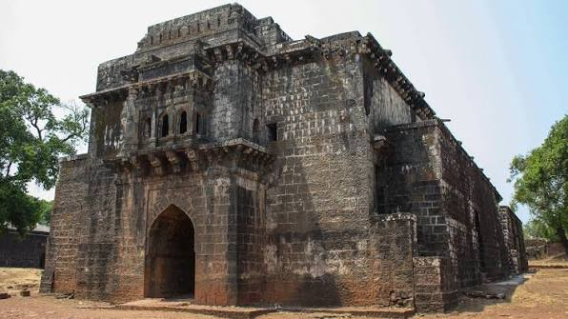

Panhala Fort, the largest fort in Deccan, is located on a hill of Sahyadri range near Kolhapur. Built by the Shilahara Dynasty, it was another intimate connection with Chhatrapati Shivaji Maharaj who used this as a political and military station in the growing Maratha Empire.
The fortress stretches across heights of more than 1,300 feet (400 meters) above sea level and is famous for its intricate fortifications, secret escape tunnels, storage facilities, and mountain vistas.
HIGHLIGHTS
- Largest Fort Of The Deccan Plateau
- Secret escape tunnels
- Maratha military history
- Scenic Sahyadri views

Best time to Explore: October to December

